Supplemental Figures: Aligning marine species range data to better serve science and conservation

Casey C. O'Hara, Jamie C. Afflerbach, Courtney Scarborough, Benjamin S. Halpern

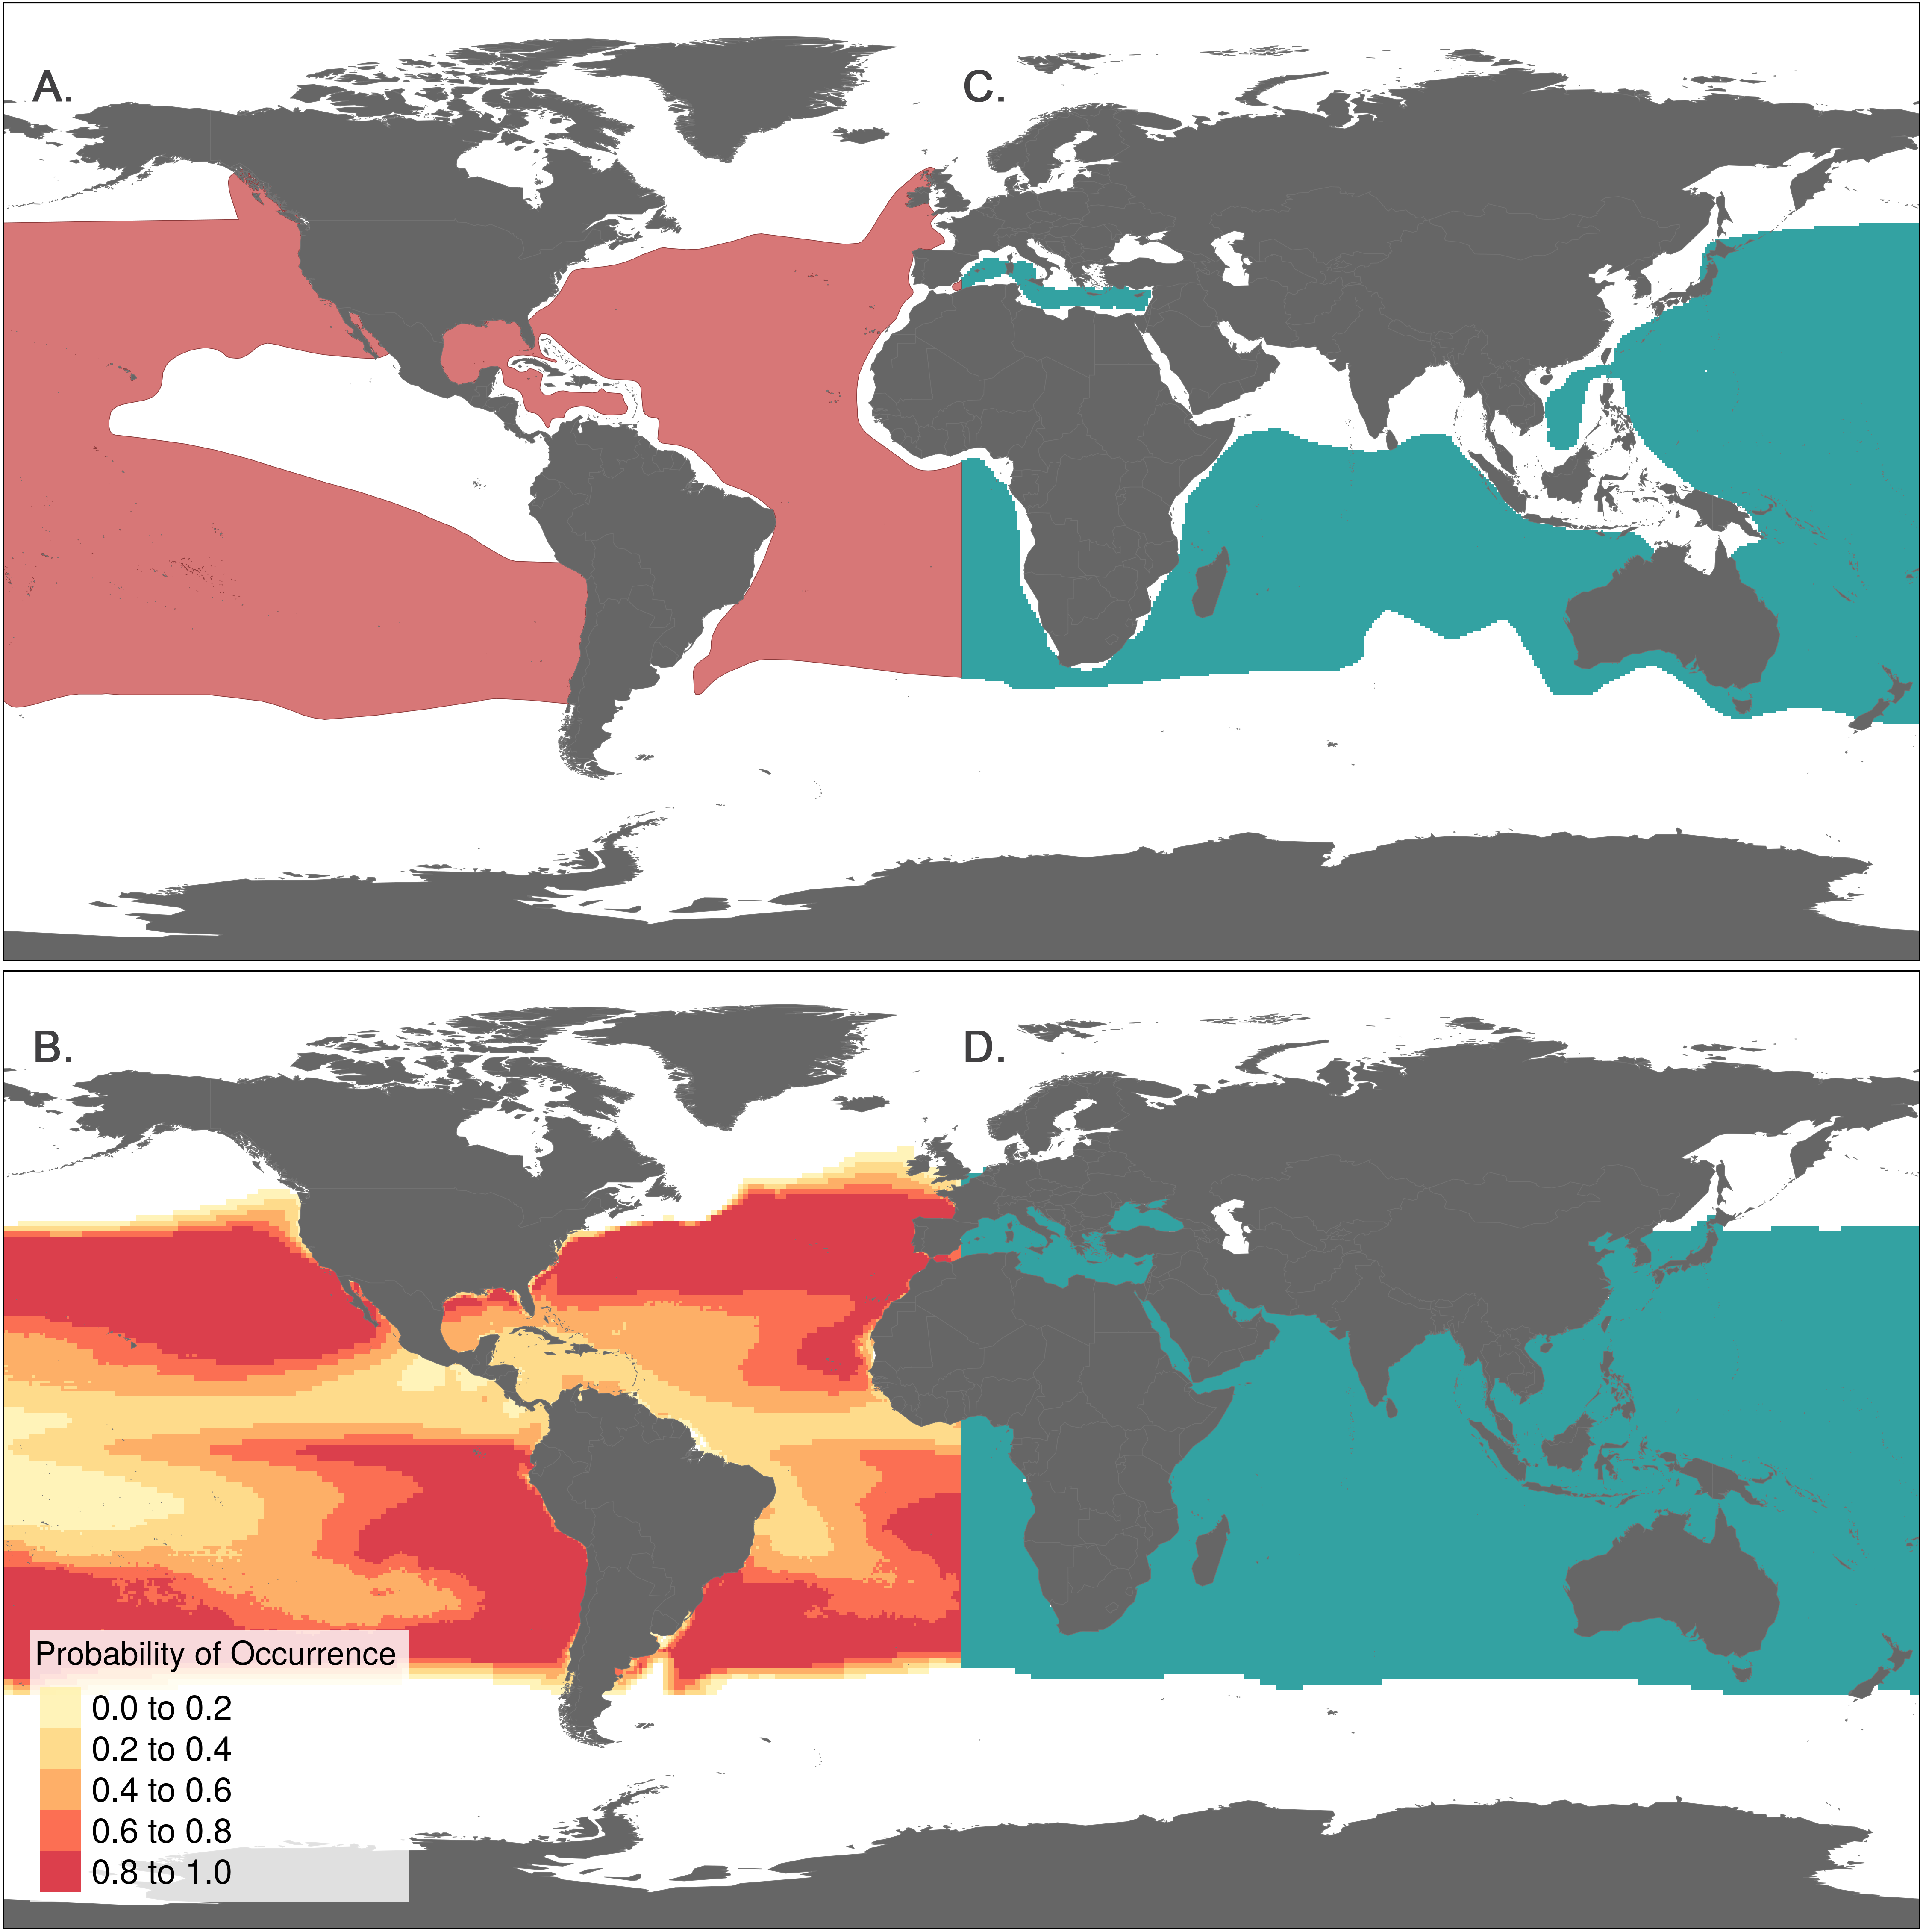

**Fig S1. Examples of AquaMaps and IUCN raw species range data.** (A, B) AquaMaps distribution of Thunnus alalunga (Albacore Tuna) [25] showing (A) global range with varying probabilities of occurrence assigned to 0.5° grid cells and (B) presence within 0.5° grid cells. (C, D) IUCN distribution of T. alalunga [26] represented as (C) extent of occurrence polygons and (D) presence within 0.5° grid cells.

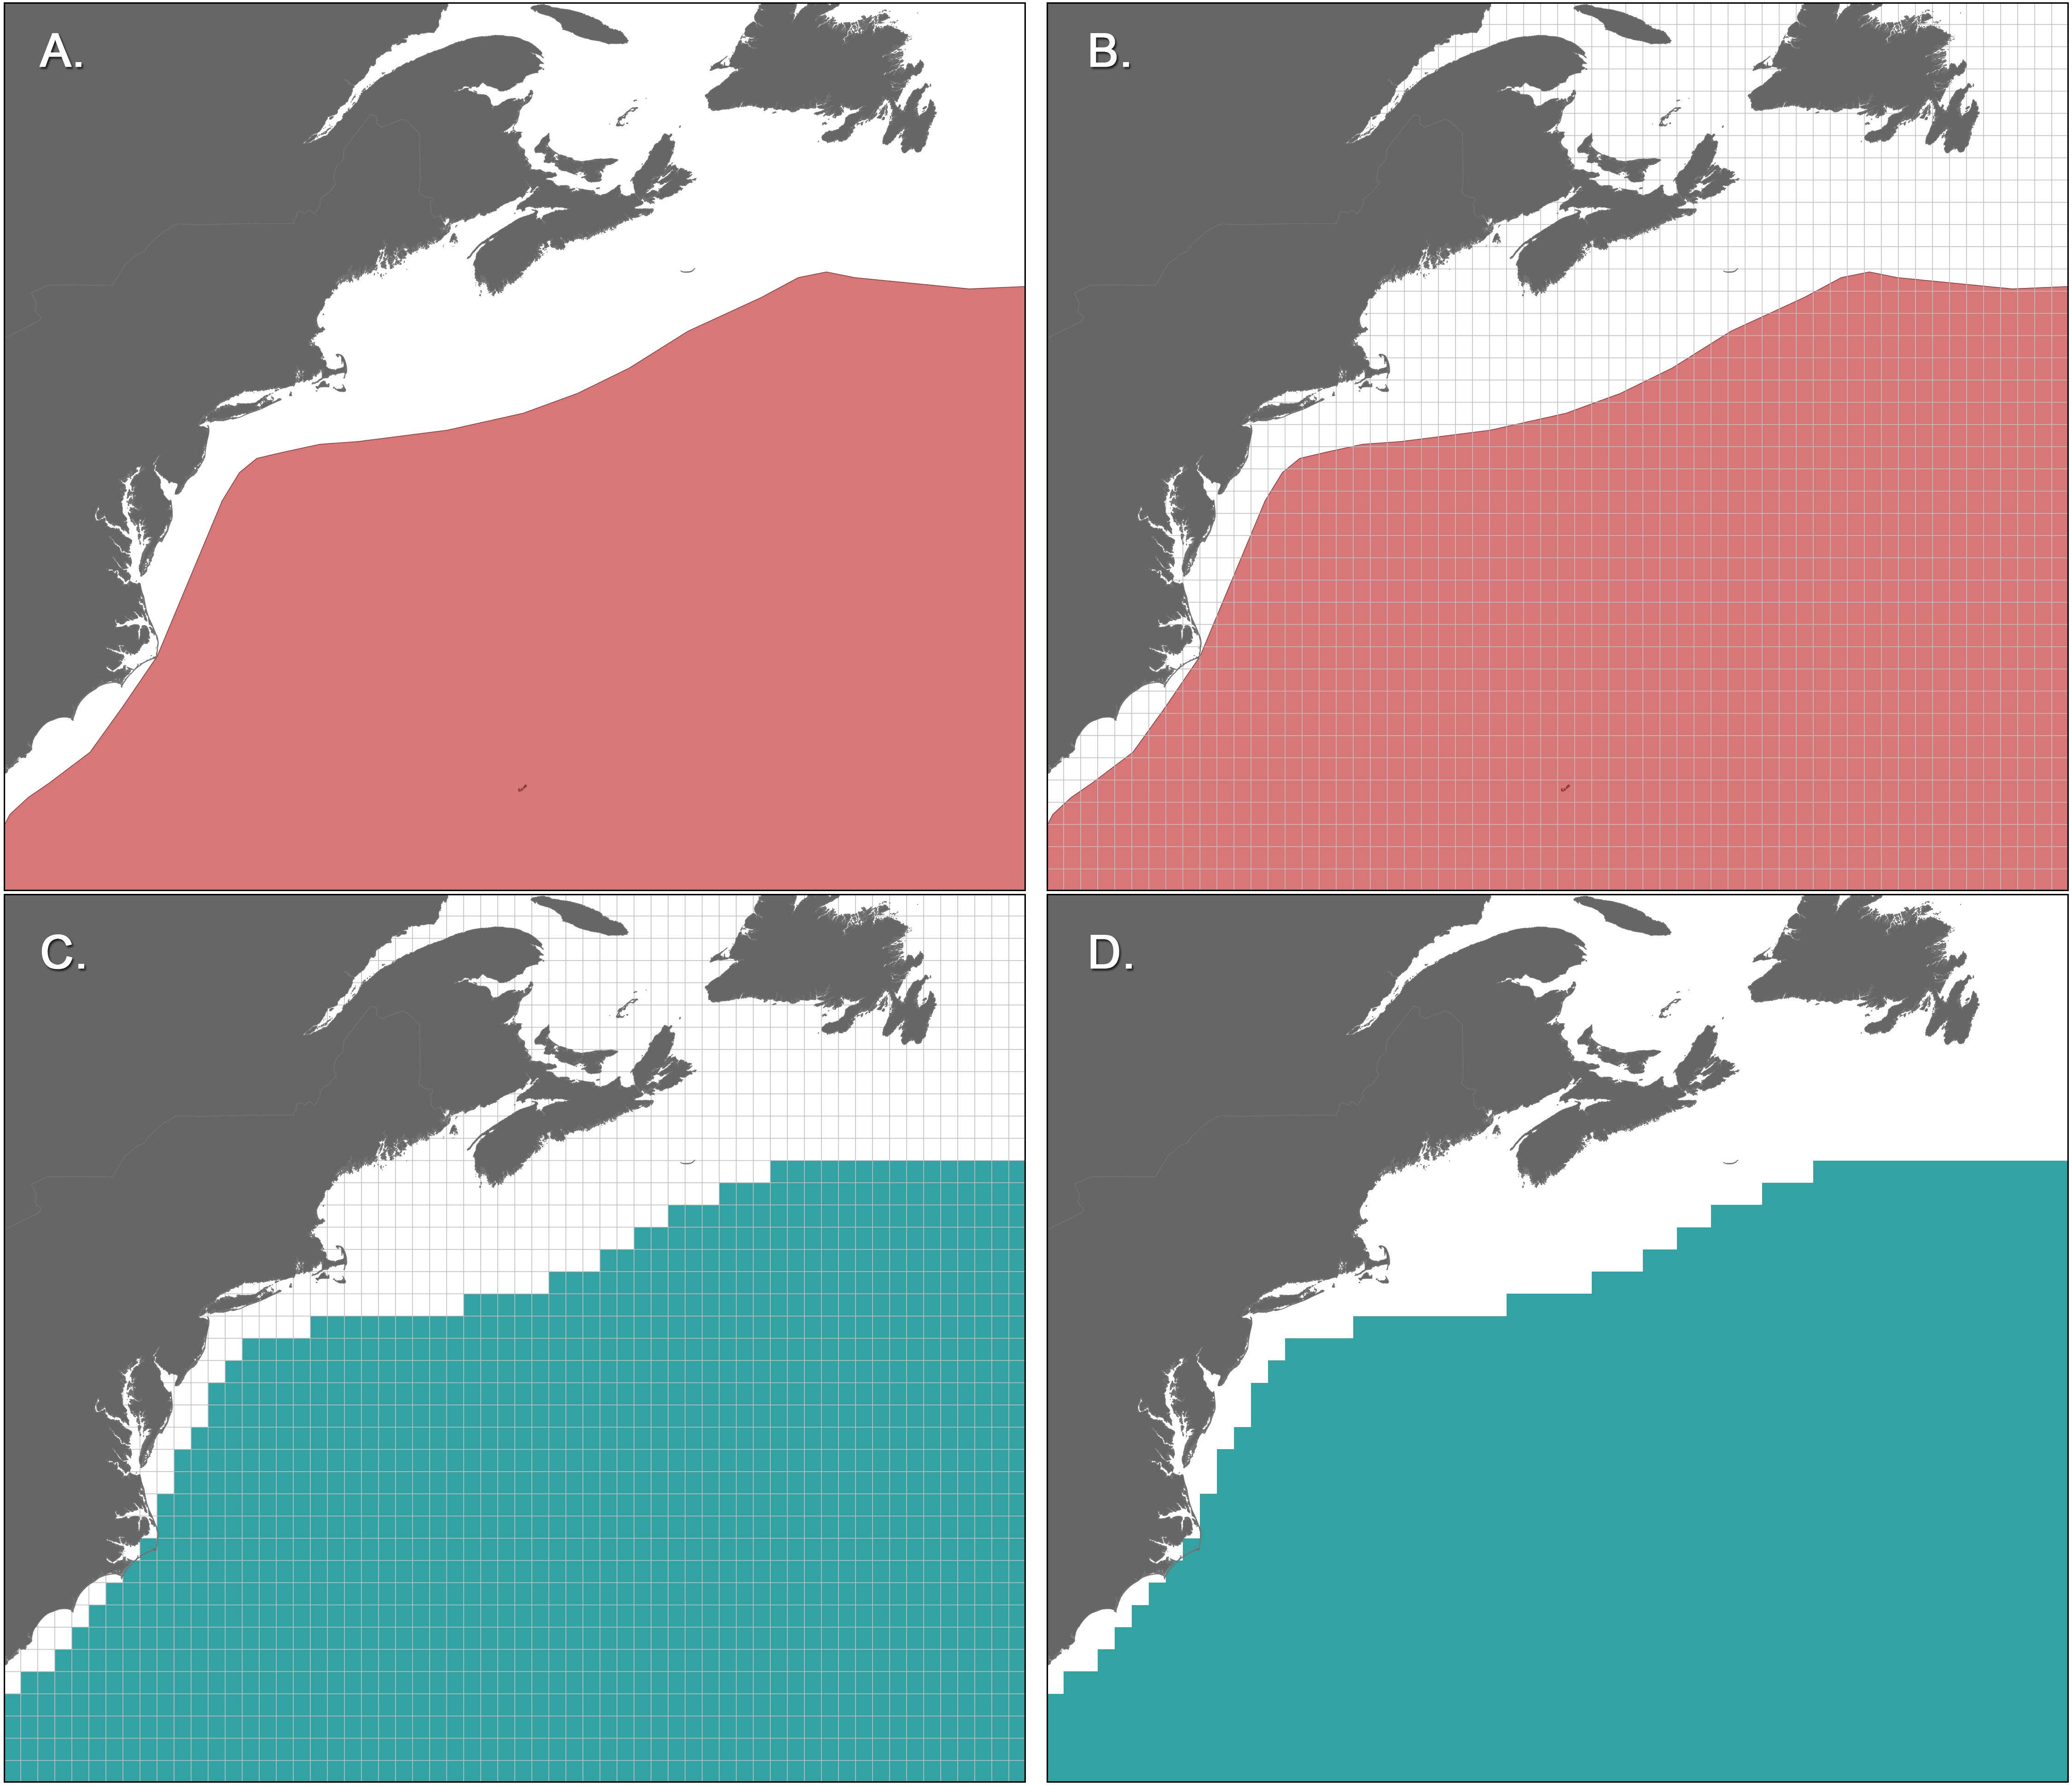

**Fig S2. Rasterizing shapefiles provided by IUCN.** A portion of the T. alalunga range map [26] is used to exemplify the rasterization process. To enable direct comparison of IUCN species ranges to AquaMaps species ranges, the raw IUCN polygon (A) is overlaid with a 0.5° degree grid matching the AquaMaps grid (B). Each cell is assigned a value of "present" if the cell overlaps any portion of the polygon (C). The resulting raster (D).

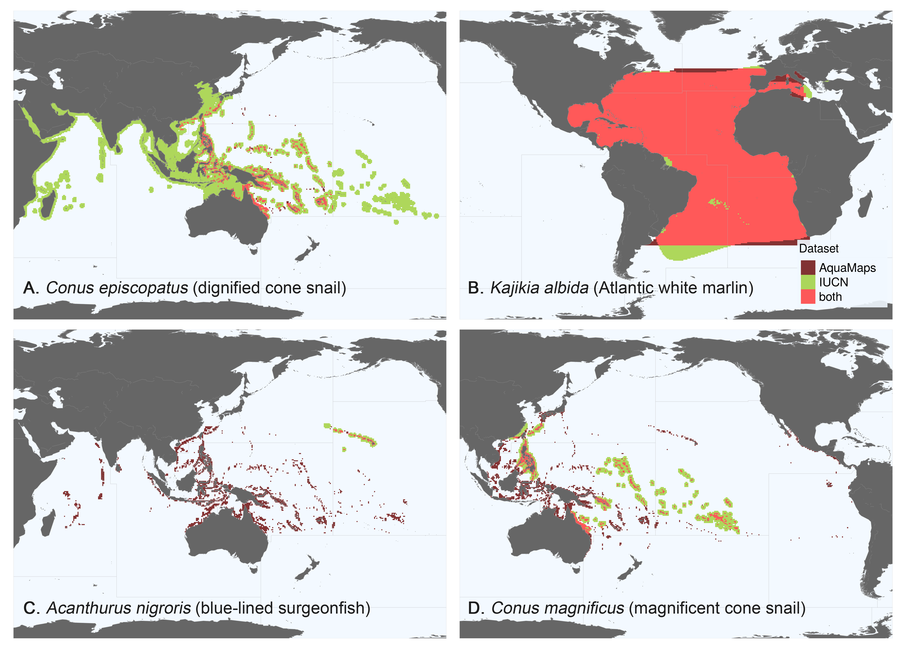

**Fig S3. Representative species maps to illustrate each quadrant from Fig 2A.** Each map is positioned to match its quadrant in Fig 2A. FAO Major Fishing Area boundaries [13] are outlined in light grey. (A) Distribution-aligned: Conus episcopatus, the dignified cone snail [27, 28]. Distributions show excellent overlap in the western Pacific, though IUCN range extends well beyond the bounds of the AquaMaps range. (B) Well-aligned: Kajikia albida, the Atlantic white marlin [29, 30]. Distributions from each data set show nearly complete overlap, and very similar range size. (C) Poorly aligned: Acanthurus nigroris, the blue-lined surgeonfish [31, 32]. IUCN predicts species distribution only near the Hawaiian islands; AquaMaps predicts extensive distribution throughout the central and western Pacific Ocean. The datasets align in neither distribution nor range size. (D) Area-aligned: Conus magnificus, the magnificent cone snail [33, 34]. Distributions overlap in the southern Pacific, but align poorly elsewhere. The range sizes are similar.

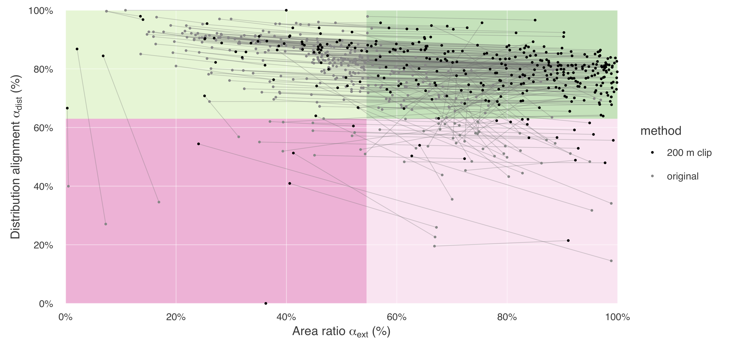

**Fig S4. Shift in alignment of paired-map coral species due to clipping IUCN ranges to areas shallower than 200 m.** The grey lines represent the change in apparent alignment for a single species. Most coral species shift rightward from the upper left quadrant to the upper right, with little if any loss in distribution alignment, since in general, only unsuitable habitat has been removed. Leftward shifts can be seen in species whose larger original range is represented in AquaMaps; by trimming IUCN ranges, the area ratio becomes smaller.

## References for supplemental figures

1. www.aquamaps.org, version of Aug. 2013. Reviewed distribution maps for Thunnus alalunga (Albacore), with modelled year 2100 native range map based on IPCC A2 emissions scenario. Web. Accessed 11 Sep. 2016.
2. International Union for Conservation of Nature (IUCN) 2011. Thunnus alalunga. The IUCN Red List of Threatened Species. Version 2016-2
3. www.aquamaps.org, version of Aug. 2013. Computer generated distribution maps for Conus episcopatus, with modelled year 2100 native range map based on IPCC A2 emissions scenario. Web. Accessed 11 Sep. 2016.
4. Conch Books, Hackenheim, Germany 2013. Conus episcopatus. The IUCN Red List of Threatened Species. Version 2016-2.
5. www.aquamaps.org, version of Aug. 2013. Computer generated distribution maps for Kajikia albida (Atlantic white marlin), with modelled year 2100 native range map based on IPCC A2 emissions scenario. Web. Accessed 11 Sep. 2016.
6. International Union for Conservation of Nature (IUCN) 2011. Kajikia albida. The IUCN Red List of Threatened Species. Version 2016-2.
7. www.aquamaps.org, version of Aug. 2013. Reviewed distribution maps for Acanthurus nigroris (Bluelined surgeonfish), with modelled year 2100 native range map based on IPCC A2 emissions scenario. Web. Accessed 11 Sep. 2016.
8. International Union for Conservation of Nature (IUCN) 2012. Acanthurus nigroris. The IUCN Red List of Threatened Species. Version 2016-2.
9. www.aquamaps.org, version of Aug. 2013. Computer generated distribution maps for Conus magnificus, with modelled year 2100 native range map based on IPCC A2 emissions scenario. Web. Accessed 11 Sep. 2016.
10. Conch Books, Hackenheim, Germany 2013. Conus magnificus. The IUCN Red List of Threatened Species. Version 2016-2.